CS 6301.012
Advanced Computing for Data Science
Assignment III

Sushmitha Mohan Raj sxm144630
Sreesha Nagaraj sxn1446630

Predicting Car Trade In Value
The below code builds a Multilinear regression model(Already done in assignment 2) and uses stepAIC to remove the unwanted attributes from the data set.
library("MASS", lib.loc="C:/Program Files/R/R-3.2.3/library")
stepFunction=stepAIC(linearReg_CarTrade, direction = "backward")
stepFunction$anova

Stepwise Model Path
Analysis of Deviance Table

Initial Model:
Price ~ Mileage + Make + Model + Trim + Type + Liter + Cylinder.factor +
Doors.factor + Cruise.factor + Sound.factor + Leather.factor

Final Model:
Price ~ Mileage + Model + Trim + Sound.factor + Leather.factor
Analysis of Variance Table

Response: Price
Df Sum Sq Mean Sq F value Pr(>F)
Mileage 1 1.2063e+09 1206304182 1444.5886 < 2.2e-16 ***
Model 31 6.0905e+10 1964689212 2352.7794 < 2.2e-16 ***
Trim 38 1.4766e+09 38857779 46.5335 < 2.2e-16 ***
Sound.factor 1 3.3336e+06 3333628 3.9921 0.0461781 *
Leather.factor 1 1.0758e+07 10758385 12.8835 0.0003594 ***
Residuals 582 4.8600e+08 835050
---
Signif. codes: 0 ‘***’ 0.001 ‘**’ 0.01 ‘*’ 0.05 ‘.’ 0.1 ‘ ’ 1

The attributes Mileage + Model + Trim + Sound.factor + Leather.factor were the attributes used to build the model.

vif(stepFunction)

The VIF(Variance Inflation Factor) is used to compute the collinearity between the attributes.

Note: The VIF function did not execute with the TRIM attribute included. As it did not have any variance. So vif had to be used excluding the TRIM attribute from the model.

lm.fit=update(stepFunction, ~.-Trim)
vif(lm.fit)
vifFunction=vif(lm.fit)
anova(lm.fit)

Analysis of Variance Table

Response: Price
Df Sum Sq Mean Sq F value Pr(>F)
Mileage 1 1.2063e+09 1206304182 386.6120 < 2.2e-16 ***
Model 31 6.0905e+10 1964689212 629.6690 < 2.2e-16 ***
Sound.factor 1 1.3818e+05 138181 0.0443 0.8333917
Leather.factor 1 4.2029e+07 42028675 13.4699 0.0002633 ***
Residuals 620 1.9345e+09 3120194
---
Signif. codes: 0 ‘***’ 0.001 ‘**’ 0.01 ‘*’ 0.05 ‘.’ 0.1 ‘ ’ 1

vifFunction
GVIF Df GVIF^(1/(2*Df))
Mileage 1.051743 1 1.025545
Model 2.089413 31 1.011956
Sound.factor 1.279111 1 1.130978
Leather.factor 1.605621 1 1.267131

The VIF function does not have any significantly high values. Thus there is no much collinearity among attributes.
mseAfterVIF=mse(testSetCarTrade$Price,predictScoresCarsWorth)
mseAfterVIF
[1] 3473001

This was the MSE calculated for the model excluding TRIM.
Residual Plots
The model was built with attributes attributes Mileage + Model+ Sound.factor + Leather.factor

plot(predict(stepFunction), residuals(stepFunction))
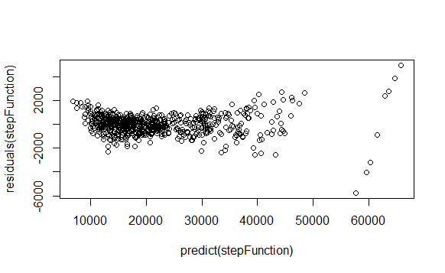
The plot seems to show to show non-linear influence in the model.
Following are the plots tried with various interaction terms.
The first model was with one continuous data and a categorical data.
Car.model1=lm(Price~Mileage*Model+Trim+Sound.factor+Leather.factor)
plot(predict(Car.model1), residuals(Car.model1)
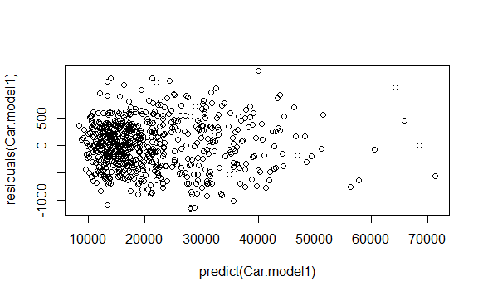

anova(Car.model1)
Analysis of Variance Table

Response: Price
Df Sum Sq Mean Sq F value Pr(>F)
Mileage 1 1.2063e+09 1206304182 5268.513 < 2.2e-16 ***
Model 31 6.0905e+10 1964689212 8580.746 < 2.2e-16 ***
Trim 38 1.4766e+09 38857779 169.711 < 2.2e-16 ***
Sound.factor 1 3.3336e+06 3333628 14.560 0.0001512 ***
Leather.factor 1 1.0758e+07 10758385 46.987 1.921e-11 ***
Mileage:Model 31 3.5984e+08 11607731 50.697 < 2.2e-16 ***
Residuals 551 1.2616e+08 228965

Car.model2=lm(Price~Mileage+Model*Trim+Sound.factor+Leather.factor)
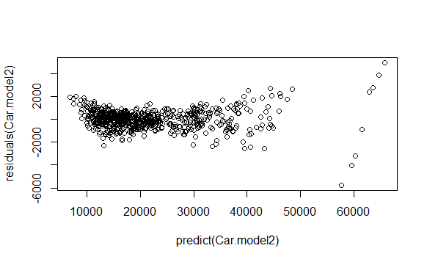
anova(Car.model2)
Analysis of Variance Table

Response: Price
Df Sum Sq Mean Sq F value Pr(>F)
Mileage 1 1.2063e+09 1206304182 1436.7312 < 2.2e-16 ***
Model 31 6.0905e+10 1964689212 2339.9822 < 2.2e-16 ***
Trim 38 1.4766e+09 38857779 46.2804 < 2.2e-16 ***
Sound.factor 1 3.3336e+06 3333628 3.9704 0.0467795 *
Leather.factor 1 1.0758e+07 10758385 12.8134 0.0003733 ***
Model:Trim 8 4.0591e+06 507382 0.6043 0.7746085
Residuals 574 4.8194e+08 839617

plot(predict(Car.model3), residuals(Car.model3))
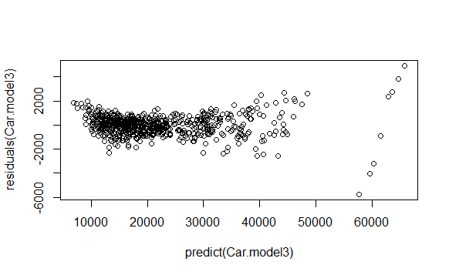
anova(Car.model3)
Analysis of Variance Table

Response: Price
Df Sum Sq Mean Sq F value Pr(>F)
Mileage 1 1.2063e+09 1206304182 1442.3479 < 2.2e-16 ***
Model 31 6.0905e+10 1964689212 2349.1299 < 2.2e-16 ***
Trim 38 1.4766e+09 38857779 46.4613 < 2.2e-16 ***
Sound.factor 1 3.3336e+06 3333628 3.9859 0.0463477 *
Leather.factor 1 1.0758e+07 10758385 12.8635 0.0003633 ***
Sound.factor:Leather.factor 1 8.1337e+04 81337 0.0973 0.7552639
Residuals 581 4.8592e+08 836348

summary(Car.model1)
Residual standard error: 478.5 on 551 degrees of freedom
Multiple R-squared: 0.998, Adjusted R-squared: 0.9977

summary(stepFunction)

Residual standard error: 913.8 on 582 degrees of freedom
Multiple R-squared: 0.9924, Adjusted R-squared: 0.9915

It can be inferred from the above summaries that the model built with interaction term has slightly higher R-squared value compared to that of the stepfunction model. And there were few other models Car.model2 Car.model3 which weren’t as good as Car.model1.
Studentized residuals
Car.model1=lm(Price~Mileage*Model+Trim+Sound.factor+Leather.factor)
plot(predict(Car.model1), rstudent(Car.model1))
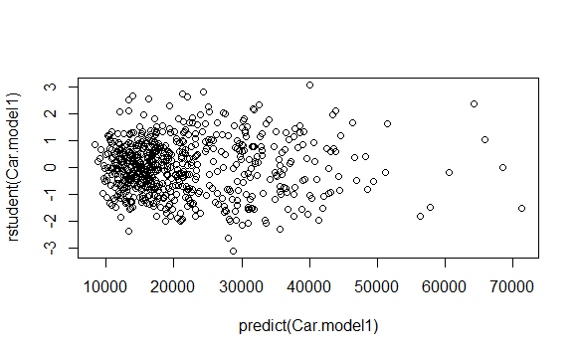
There is no indication of a non-linear pattern. The studentized residuals for the following other models seems to show patterns.

plot(predict(Car.model2), rstudent(Car.model2))

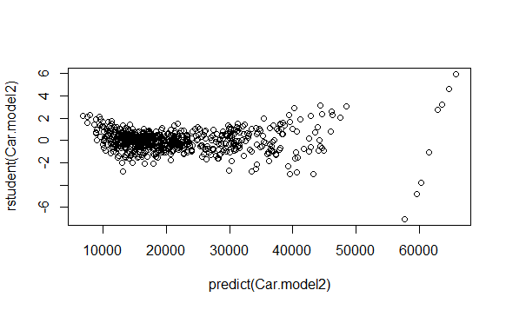
plot(predict(Car.model3), rstudent(Car.model3))
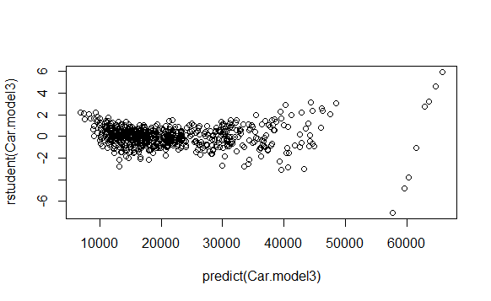

Leverage with hatvalues
plot(hatvalues(Car.model1), type = "h")
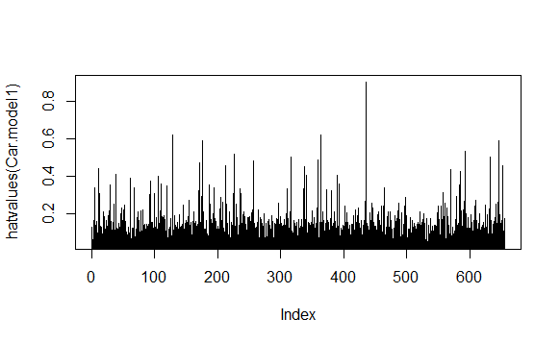
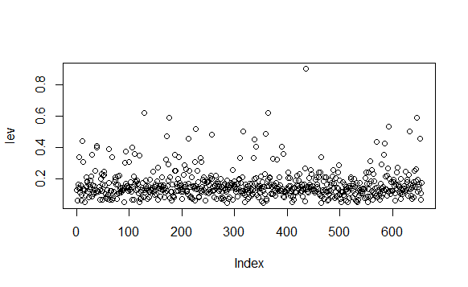
lev = hat(model.matrix(Car.model1))
plot(lev)
trainSetCarTrade[lev>.8,]
Price Mileage Make Model Trim Type Cylinder Liter Doors Cruise
435 27280.98 4836 SAAB 9-2X AWD Linear Wagon 4D Wagon 4 2.5 4 1
Sound Leather
435 1 0

The outlier seems to be the data at index 435.

Predicting Carbon Monoxide Levels in Cigarettes:
linear regression model
lm.fitCigarettes=lm(CO~., data = CigarettesData)
summary(lm.fitCigarettes)
Residual standard error: NaN on 0 degrees of freedom
Multiple R-squared: 1, Adjusted R-squared: NaN
F-statistic: NaN on 24 and 0 DF, p-value: NA

The summary throws a lot of NaN’s. This is because the attribute BRAND does not seem to have any variance. Thus it can be concluded that its not a Predictor but just an Identifier.
lm.fitCigarettesUpdate=update(lm.fitCigarettes, ~.-Brand)
stepAICForCigarette=stepAIC(lm.fitCigarettesUpdate, direction = "backward")
Using the stepAIC we build the model by removing the unwanted attributes
anova(stepAICForCigarette)

Analysis of Variance Table

Response: CO
Df Sum Sq Mean Sq F value Pr(>F)
Tar 1 494.28 494.28 253.37 6.552e-14 ***
Residuals 23 44.87 1.95

The StepAIC build the model with the attribute “Tar”.

plot(predict(stepAICForCigarette), residuals(stepAICForCigarette))
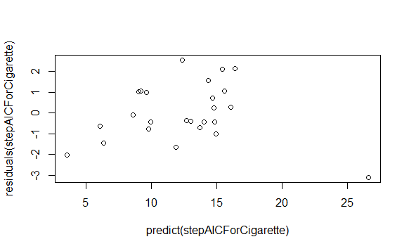
plot(predict(stepAICForCigarette), rstudent(stepAICForCigarette))
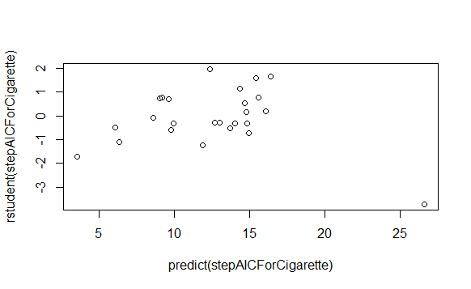

lm.fitMultiLinear=lm(CO~Tar*Nicotine)
summary(lm.fitMultiLinear)
Call:
lm(formula = CO ~ Tar * Nicotine)

Residuals:
Min 1Q Median 3Q Max
-2.0304 -0.7462 -0.1666 0.9340 2.1433

Coefficients:
Estimate Std. Error t value Pr(>|t|)
(Intercept) 0.27558 1.06539 0.259 0.79841
Tar 1.07127 0.19579 5.471 1.99e-05 ***
Nicotine 2.06174 3.37822 0.610 0.54821
Tar:Nicotine -0.20983 0.06059 -3.463 0.00233 **
---
Signif. codes: 0 ‘***’ 0.001 ‘**’ 0.01 ‘*’ 0.05 ‘.’ 0.1 ‘ ’ 1

Residual standard error: 1.153 on 21 degrees of freedom
Multiple R-squared: 0.9482, Adjusted R-squared: 0.9408
F-statistic: 128.1 on 3 and 21 DF, p-value: 1.175e-13

vif(lm.fitMultiLinear)
Tar Weight Tar:Weight
55.099261 3.375712 67.167879

outlierTest(stepAICForCigarette)
rstudent unadjusted p-value Bonferonni p
3 -3.722367 0.0011842 0.029605

The outlier seems to be at index 3. Also the inference from the residual plot and the studentized residual shows there is collinear influence with the attributes used to build the model.

Predicting Low Birth Weight:
Logistic model that predicts the LOW variable

The logistic model was built excluding BWT and ID
glm.fit=glm(Low.factor~ AGE+LWT+Race.factor+Smoke.factor+PTL.factor+HT.factor+UI.factor+FTV.factor, data = Lowbwtdata, family = binomial)

summary(glm.fit)$coef
Estimate Std. Error z value Pr(>|z|)
(Intercept) 0.89861468 1.298991e+00 0.691779007 0.489076122
AGE -0.03889543 3.952510e-02 -0.984069051 0.325081563
LWT -0.01535517 7.482958e-03 -2.052018734 0.040167842
Race.factor2 1.11046622 5.508737e-01 2.015827422 0.043818025
Race.factor3 0.66975620 4.773621e-01 1.403035963 0.160606115
Smoke.factor1 0.70730863 4.398767e-01 1.607970073 0.107841733
PTL.factor1 1.86503770 5.722067e-01 3.259377817 0.001116569
PTL.factor2 0.48748803 1.007786e+00 0.483721936 0.628583223
PTL.factor3 -15.53391013 1.455398e+03 -0.010673310 0.991484093
HT.factor1 1.80473633 7.488183e-01 2.410112511 0.015947602
UI.factor1 0.79304539 4.780390e-01 1.658955304 0.097124799
FTV.factor1 -0.55984678 4.957678e-01 -1.129251935 0.258791571
FTV.factor2 -0.08140614 5.447005e-01 -0.149451190 0.881197621
FTV.factor3 1.10309950 8.648316e-01 1.275507820 0.202129558
FTV.factor4 -0.92247233 1.383642e+00 -0.666698496 0.504964740
FTV.factor6 -12.91388335 1.455398e+03 -0.008873094 0.992920388

The P value for PTL and UI seems to be very low which is good indicator for a predictor variable.

contrasts(Low.factor)
1
0 0
1 1
glm.probs=predict(glm.fit,type = "response")
glm.probs[1:10]
1 2 3 4 5 6 7 8
0.32485957 0.27049156 0.20683255 0.46068141 0.51395833 0.24003746 0.08876232 0.22543309
9 10
0.12232695 0.24223004

glm.pred=rep("Normal",189)
glm.pred[glm.probs>.5]="Low"
table(glm.pred,Low.factor)
Low.factor
glm.pred 0 1
Low 14 29
Normal 116 30

The Accuracy was calculated from the confusion matrix as 76.71%
(116+29)/189 = 0.7671

#Code used in the assignment

Predicting Car Trade In Value
trainSetCarTrade=read.table("C:\\Users\\Sushmitha\\Documents\\Third Semester\\Comp Mthds Data Science\\Assignment II\\CarWorthTrain.csv",",",header = TRUE)
names(trainSetCarTrade)
library("car", lib.loc="~/R/win-library/3.2")
testSetCarTrade=read.table("C:\\Users\\Sushmitha\\Documents\\Third Semester\\Comp Mthds Data Science\\Assignment II\\CarWorthTest.csv",",",header = TRUE)
attach(trainSetCarTrade)
Cylinder.factor=factor(Cylinder)
Doors.factor=factor(Doors)
Cruise.factor=factor(Cruise)
Sound.factor=factor(Sound)
Leather.factor=factor(Leather)
linearReg_CarTrade=lm(Price~Mileage+Make+Model+Trim+Type+Liter+Cylinder.factor+Doors.factor+Cruise.factor+Sound.factor+Leather.factor)
stepFunction=stepAIC(linearReg_CarTrade, direction = "backward")
library("Metrics", lib.loc="~/R/win-library/3.2")
stepFunction=stepAIC(linearReg_CarTrade, direction = "backward")
library("MASS", lib.loc="C:/Program Files/R/R-3.2.3/library")
stepFunction=stepAIC(linearReg_CarTrade, direction = "backward")
vif(stepFunction)
upadatedModel=update(stepFunction, ~.-Trim)
lm.fit=update(stepFunction, ~.-Trim)
vifFunction=vif(lm.fit)
summary(stepFunction)
summary(lm.fit)
SoundTest.factor=testSetCarTrade$Sound
LeaterTest.factor=testSetCarTrade$Leather
MileageTest=testSetCarTrade$Mileage
Modeltest=testSetCarTrade$Model
TrimTest=testSetCarTrade$Trim
SoundTest.factor=factor(testSetCarTrade$Sound)
is.factor(LeaterTest.factor)
LeatherTest.factor=factor(testSetCarTrade$Leather)
predictScoresCarsWorth=predict(lm.fit,data.frame(Mileage=MileageTest,Model=Modeltest,Sound.factor=SoundTest.factor,Leather.factor=LeatherTest.factor))
mseAfterVIF=mse(testSetCarTrade$Price,predictScoresCarsWorth)
mseAfterVIF

plot(predict(stepFunction), residuals(stepFunction))

Car.model1=lm(Price~Mileage*Model+Trim+Sound.factor+Leather.factor)
anova(Car.model1)
plot(predict(Car.model1), residuals(Car.model1))
plot(predict(Car.model1), rstudent(Car.model1))
summary(Car.model1)

Car.model2=lm(Price~Mileage+Model*Trim+Sound.factor+Leather.factor)
anova(Car.model2)
plot(predict(Car.model2), residuals(Car.model2))
plot(predict(Car.model2), rstudent(Car.model2))

Car.model3=lm(Price~Mileage+Model+Trim+Sound.factor*Leather.factor)
anova(Car.model3)
plot(predict(Car.model3), residuals(Car.model3))
plot(predict(Car.model3), rstudent(Car.model3))

plot(hatvalues(Car.model1), type = "h")
hatvalues(Car.model1)
which.max(hatvalues(Car.model1))

lev = hat(model.matrix(Car.model1))
plot(lev)
trainSetCarTrade[lev>.8,]

Predicting Carbon Monoxide Levels in Cigarettes
CigarettesData=read.table("C:\\Users\\Sushmitha\\Documents\\Third Semester\\Comp Mthds Data Science\\Assignment III\\cigarettes-data.csv",",",header = TRUE)
lm.fitCigarettes=lm(CO~., data = CigarettesData)
summary(lm.fitCigarettes)

//No variance in Brand; not a predictor just an identifier
lm.fitCigarettesUpdate=update(lm.fitCigarettes, ~.-Brand)
stepAICForCigarette=stepAIC(lm.fitCigarettesUpdate, direction = "backward")
anova(stepAICForCigarette)
anova(lm.fitCigarettesUpdate)
plot(predict(stepAICForCigarette), residuals(stepAICForCigarette))
plot(predict(stepAICForCigarette), rstudent(stepAICForCigarette))
lm.fitMultiLinear=lm(CO~Tar*Nicotine)
summary(lm.fitMultiLinear)
vif(lm.fitMultiLinear)
outlierTest(stepAICForCigarette)
boxplot(Tar,CO)

Predicting Low Birth Weight
Lowbwtdata=read.table("C:\\Users\\Sushmitha\\Documents\\Third Semester\\Comp Mthds Data Science\\Assignment III\\lowbwt.csv",",",header = TRUE)
dim(Lowbwtdata)
names(Lowbwtdata)
Low.factor=factor(LOW)
Race.factor=factor(RACE)
Smoke.factor=factor(SMOKE)
PTL.factor=factor(PTL)
HT.factor=factor(HT)
UI.factor=factor(UI)
FTV.factor=factor(FTV)
glm.fit=glm(Low.factor~ AGE+LWT+Race.factor+Smoke.factor+PTL.factor+HT.factor+UI.factor+FTV.factor, data = Lowbwtdata, family = binomial)
summary(glm.fit)$coef
glm.probs=predict(glm.fit,type = "response")
glm.probs[1:10]
contrasts(Low.factor)
glm.pred=rep("Normal",189)
glm.pred[glm.probs>.5]="Low"
table(glm.pred,Low.factor)
anova(glm.fit)

